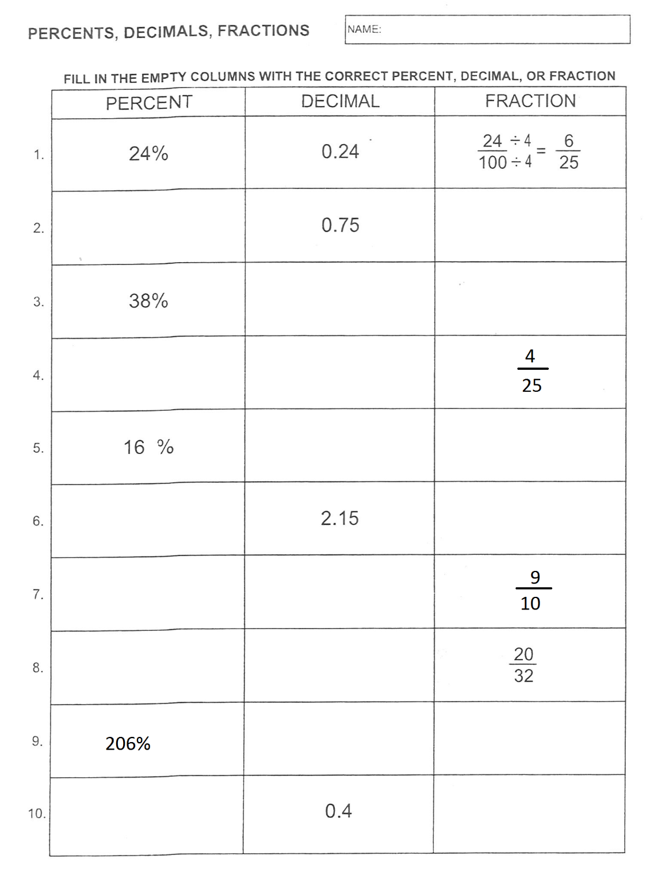 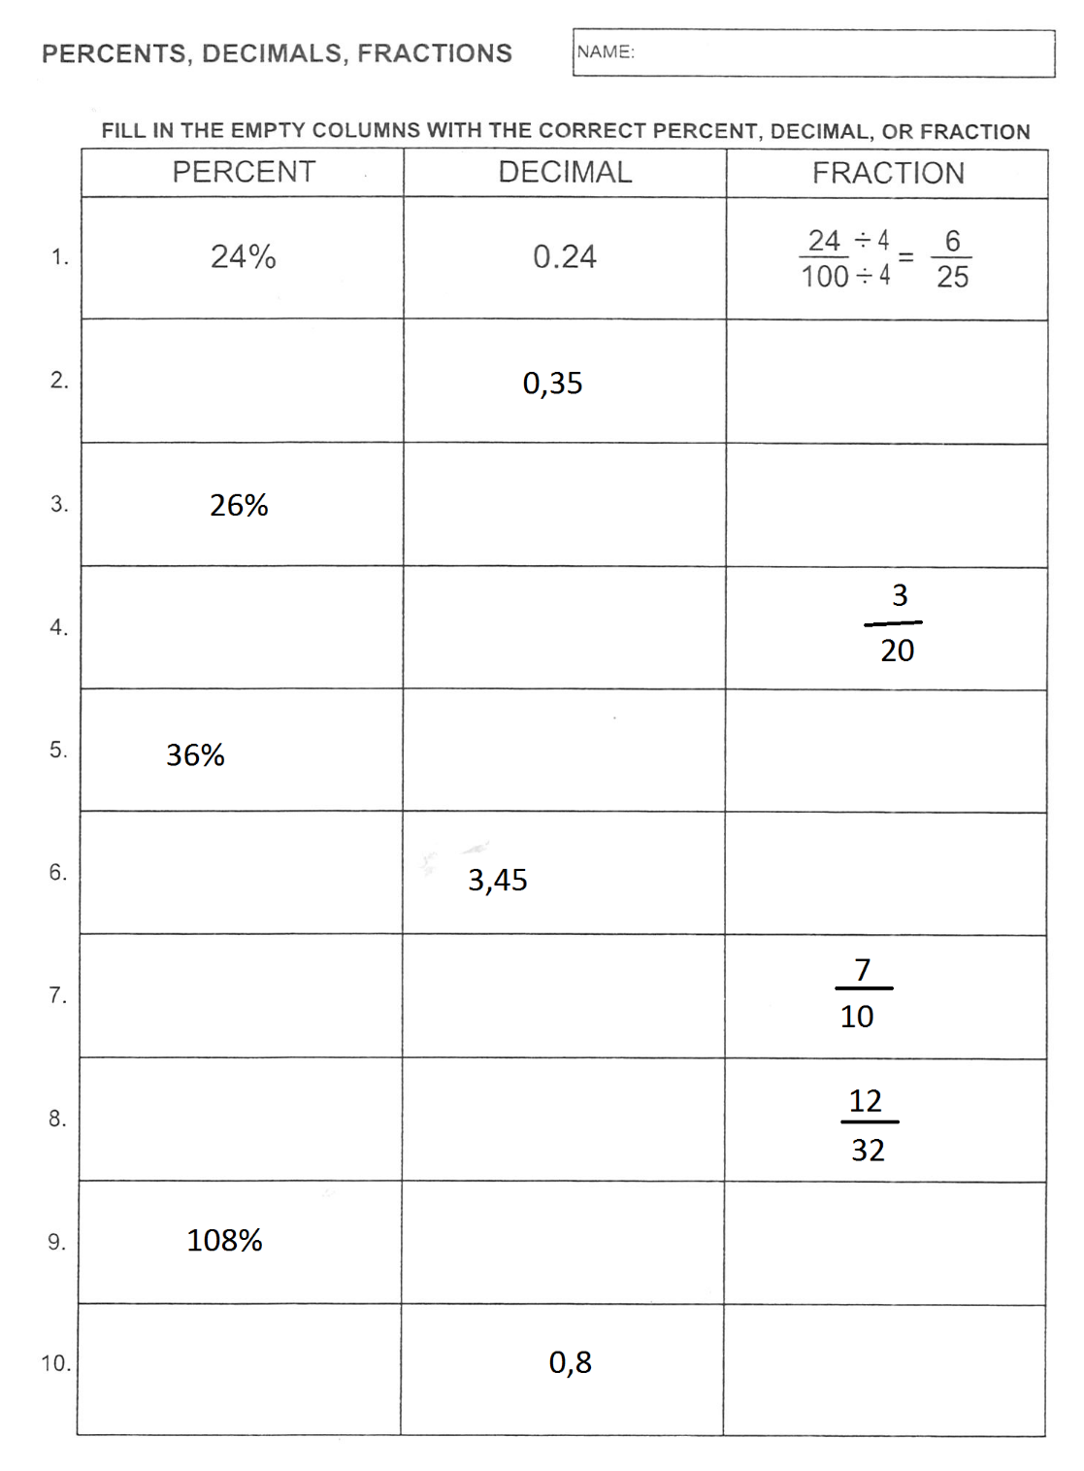

|  |  |
| --- | --- |
| 1. 25% no 0,16 = 2. 80 % no = 3. 75% no 2,4 = | 1. 20 % no 0, 25 = 2. 60 % no = 3. 75% no 3,6 = |